Homework July 17, 2021

Write a Python script to concatenate dictionaries to create a new one.

Example:  
dic1={1:10, 2:20}  
dic2={3:30, 4:40}  
dic3={5:50,6:60}  
Result: {1: 10, 2: 20, 3: 30, 4: 40, 5: 50, 6: 60}

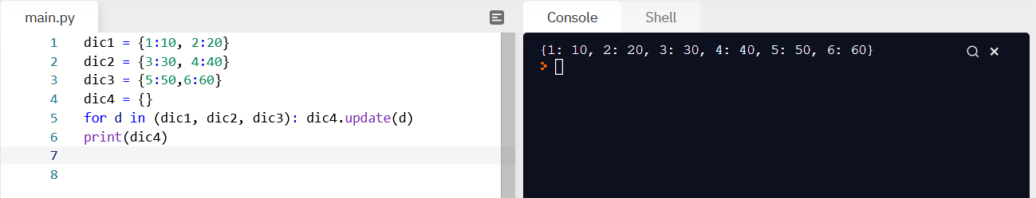

Write a Python program to count the number of characters (character frequency) in a string.  
Example: "[google.com](http://google.com)"  
Result : {'g': 2, 'o': 3, 'l': 1, 'e': 1, '.': 1, 'c': 1, 'm': 1}

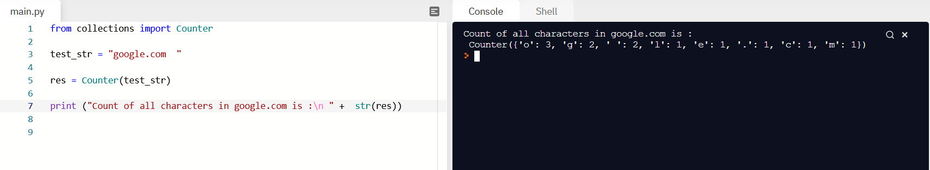

Introduction to UX

1. What is the purpose of UX?

UX describes the user experience and the goal is the make it as easy, pleasant, and intuitive as possible.

2. What is A/the prime objective?

It is the main purpose of the site/app.

3. What is a User Story and what is its purpose in UX?

A User Story is placing oneself in the role of a user and describing what must be done for a specific task. It allows the developer to figure out needs and issues that may arise while using the site.

4. What is a feature list?

It’s a list of features a site/app should have.

5. What is a sitemap?

It is a diagram of the showing where each feature on the site navigates to.

6. What is a low fidelity wireframe?

It is a rough draft on how the site will look.

7. What is a High fidelity wireframe or mockup?

It is a draft on how the site will look using a program that will allow one to make a detailed representation of how a site/app will appear.

8. What does UX stand for?

User Experience.

UI for Developers

1. What is the purpose of UI?

UI is the user interface and so it is the visual interface the user sees of a site/app.

2. What is typography?

It is the font, type-set, and general styling of text.

3. What is a UI Color Scheme?

It’s the palette site/app developers decide to use for the interface.

4. What is White Space and what is it used for?

It is the margin space around the interface to create a more visually appealing site/app.

5. What are some of the Environments you will design UI for?

Websites, apps, programs, and anything needing a computer interface.

6. What is a UI style guide and what purpose does it serve.

It is a legend of all styles used for a site including colors palettes, fonts, formats and any other styling decisions so there is uniformity throughout the site/app.

7. What is the purpose of a logo and logo design?

This is a very broad question with marketing and design style studies devoted to the importance of logos and their design. They are the symbol for an entity.

8. What does UI stand for?

User Interface.

Introduction to Programming

1. What is the Zen of Python.

It’s a list of best practices when working with the language.

2. What purpose does indentation serve in Python?

It lets Python know the next step to run in a function.

3. What is a Variable in Python?

Much like math, it’s a label you assign to represent data.

4. List at least 5 Python data types.

[“String”, Boolean = True, Integer(0: ), [List], and (Tuple)]

5. List at least 2 types of comments you can use in Python.

You can use comments to #describe what a line of code is doing. You can also be sure to have descriptive names for your variables so it is easy to see what a line or lines of code are doing.

6. Are Python Strings immutable or mutable?

Immutable.

7. What is a Heredoc?

‘’’

It’s a long string.

‘’’

8. What can be stored in a Python List?

Strings, Booleans, integers, tuples, other lists.

9. Explain what a Python Dictionary is and how you might use one.

{A_Python_Dictionary_is

Keys : &Values

}

It can be called upon when needing a specific data set. Dictionaries can also be nested in other dictionaries.

10. What is a Tuple in Python?

Essentially it’s a list of strings.

11. What is a set in Python?

[It’s any given data put in brackets.]